**SpaceDuck Design Document**

In words;   
We have a GameManager class that controls what happens in game (or subclasses within the GameManager), so the point is that the PlayerController is the script that is attached to the Player, which the player controls and is able to move around, collect items and so on, this PlayerController then reports to the GameManager class what happened (Ie. Item collection and so on) which then again does all the necessary steps needed (Like telling the UIManager to update UI accordingly, SoundManager to play a sound etc.) This way, we are able to keep everything under control, and organized.

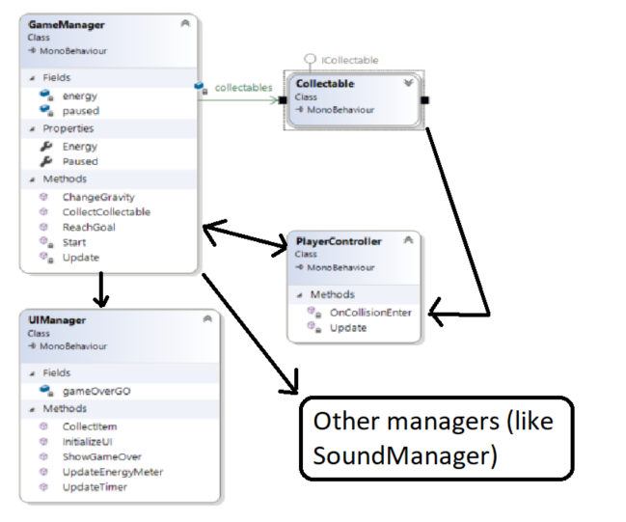

Example 1 Visualization of the flow